**Image Segmentation by Local Entropy Methods**

**Report**

**Abstract-** Image segmentation plays an important role in many image analyses, computer vision tasks, in a pre-processing phase of images having as objective a partition of the image into components or regions of interest. The technology of image segmentation is widely used in medical image processing, face recognition pedestrian detection, traffic control systems, self-driving cars, locating objects in satellite images. Image segmentation may also be used as a pre-processing phase for better image denoising or deblurring that will be done in a separate image processing phase. The current image segmentation techniques include region-based segmentation (threshold segmentation), edge detection segmentation, segmentation based on clustering. In this article, our purpose is to study mostly theoretical concepts and some experimental results for the evaluation of some image segmentation techniques and their role for a better analysis of image details.

**Keywords:** Image segmentation techniques, image denoising, multi-phase image processing, Region-based, Edge detection.

**Introduction**

Nowadays, with the rise and advancements in computer vision, machines can analyze and determine, in a matter of less than milliseconds, objects, their shape, predict the direction the objects will go in, and many other things. And this is where Image Segmentation comes into play. The goal of the segmentation problem is to represent images in a simplified and meaningful manner by partitioning them into multiple regions or components that are non-overlapping. These regions should be homogenous and uniform such as in grey levels and texture. Their interior should be simple, neighboring regions must have different values for the characteristic that is uniform for each such region, the boundaries of the segmentation regions must be simple. The aim of segmentation is a better analysis of the selected image regions or for further image processing steps. Practical applications of image segmentation include medical imaging, video surveillance, as well as means of pre-processing for a magnitude of detection and recognition tasks.

There are many commonly used image segmentation algorithms. The first is the threshold segmentation method. Threshold segmentation is one of the most commonly used segmentation techniques in region-based segmentation algorithms. Its essence is to automatically determine the optimal threshold according to a certain criterion and use these pixels according to the gray level to achieve clustering. If we want to divide the image into two regions (object and background), we define a single threshold value. This is known as the global threshold. If we have multiple objects along with the background, we must define multiple thresholds. These thresholds are collectively known as the local threshold. Followed by the regional growth segmentation. The basic idea of the regional growth algorithm is to combine the pixels with similar properties to form the region, that is, for each region to be divided first to find a seed pixel as a growth point, and then merge the surrounding neighborhood with similar properties of the pixel in its area. Then is the edge detection segmentation method. There is always an edge between two adjacent regions with different grayscale values (pixel values). The edges can be considered as the discontinuous local features of an image. We can make use of this discontinuity to detect edges and hence define a boundary of the object. This helps us in detecting the shapes of multiple objects present in a given image. This is where we can make use of filters and convolutions. The last is the segmentation based on clustering. The algorithm based on clustering is based on the similarity between things as the criterion of class division, that is, it is divided into several subclasses according to the internal structure of the sample set so that the same kind of samples are as similar as possible, and the differences are not as similar as possible. This project aims to examine results from each of the categories of algorithms.

**Theory**

Since our report is based on the study of an existing article, you can see more details in the article itself. In this section, there will be a short theory of what we have been working with. Threshold division is the best method of picture segmentation additionally one of the foremost common parallel division strategies. It could be a common division calculation that specifically partitions the picture grayscale data handling based on the gray esteem of distinctive targets. Limit segmentation can be separated into nearby limit strategy and worldwide edge strategy. The worldwide edge strategy partitions the image into two districts of the target and the foundation by a single edge. The nearby limit strategy should select numerous division edges and partition the picture into numerous target locales and foundations by different edges. The foremost commonly utilized limit division calculation is the biggest interclass change method (Otsu), which chooses a universally ideal limit by maximizing the fluctuation between classes. In addition to this, there is a co-occurrence matrix

Method, where entropy is the measure of the information content in a probability distribution. Relative entropy measures the discrepancy between two probability distributions on the same event space. To provide the probability distribution needed for the entropy measures, a co-occurrence matrix is generated from the input image. It is a mapping of the pixel to pixel greyscale transitions in the image between the neighboring pixel to the right and the pixel below each pixel in the image. From the co-occurrence matrix comes the distribution of greyscale transitions. The candidate threshold divides the co-occurrence matrix into four regions representing within the object, within the background, object to background, and background to object class transitions. Three entropies called local, joint, and global, are computed by differing combinations of the entropies of the four regions. Optimal thresholds are found by maximizing the entropies as a function of the threshold. The relative entropy is computed from the transition distributions of the original image and the segmented image. By minimizing the relative entropy as a function of threshold, the original image and segmented image transition distributions are most closely matched. To check the correctness of the method, we took this pseudocode and implemented this in Python code, and tested the method with new datasets.

**Experiment and Results**

The main idea of our experiment is to study mostly theoretical concepts and some experimental results for the evaluation of some image segmentation techniques. In order to do that, before working with our dataset, we converted all images to grayscale, so that we only have a single channel, instead of a three-channel image (RGB). The main reason for converting all data, instead of leaving it as it was, RGB image contains lots of data that may not be required for our processing. When we convert an RGB image into a grayscale we discard a lot of information which are not required for processing. And since in information theory, information entropy is the log-base-2 of the number of possible outcomes for a message. For an image, local entropy is related to the complexity contained in a given neighborhood, typically defined by a structuring element. We use an entropy filter, that will detect subtle variations in the local gray level distribution. The example shows how to detect texture in the image using a smaller structuring element:

After that using matplotlib.pyplot. subplots method that can provide a way to plot multiple plots on a single figure, we use the gray function to set the colormap to ‘gray’ and using scikit-image that has a number of automatic thresholding methods, that which require no input in choosing an optimal threshold, we implemented some of the methods:

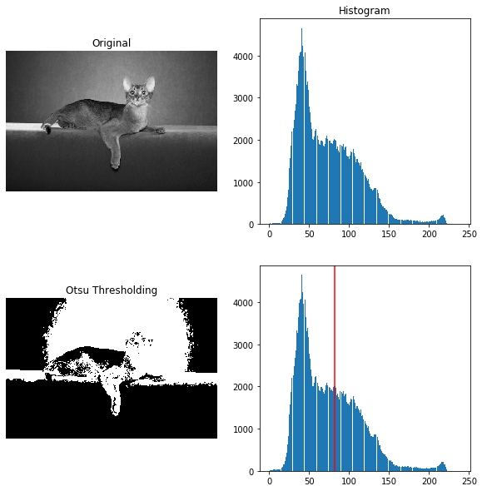

# In supervised segmentation, before doing any segmentation on an image, it is a good idea to de-noise it, using some filters. In this part we used active contour segmentation also called snakes and is initialized using a user-defined contour or line, around the area of interest, and this contour then slowly contracts and is attracted or repelled from light and edges. By creating a function, we generate points that define a circle on an image and center refers to the center of the circle. We calculated x and y coordinates of the points on the periphery of the circle. Since we have given the resolution to be 200, it will calculate 200 such points. The algorithm then segments the face of a person from the rest of an image by fitting a closed curve to the edges of the face.

**Conclusion**

In conclusion, image segmentation is a very important image processing step. As the result, the outcome obtained using one segmentation approach may not be the same as compared with another approach. In spite of research, there is no universally accepted image segmentation algorithm since image segmentation is affected by lots of factors such as type of image, color, intensity, level of noise, etc. Thus there is no single algorithm that is applicable to all types of images and the nature of the problem. Therefore, due to all the above factors, image segmentation still remains a big pending problem in the areas of image processing.

**References:**

[1] Image Segmentation by Local Entropy Methods, (Mark L. G. Althouse Edgewood Research Development & Engineering Center U.S. Army Chemical and Biological Defense Command Aberdeen Proving Ground, MD 2 10 10 USA Chein-I Chang Department of Electrical Engineering University of Maryland, Baltimore County Baltimore, MD 21228 lJSA)

[2] Comparing Supervised vs. Unsupervised Image Segmentation Methods (Guang Wei Yu University of Toronto; Richard Zemel Dept. of Computer Science University of Toronto)

[3] Image Segmentation Processing - some techniques and experimental results A comparative study of the concepts of some segmentation techniques (Mircea Weingart University “Politehnica”, Faculty of Electronics)

[4] A Review on Image Processing and Image Segmentation. ( Jiss Kuruvilla Assistant Professor, Dept. of Computer Applications,2016 International Conference on Data Mining and Advanced Computing (SAPIENCE))

[5] Li, Shu Tao, et al. "Pixel-level image fusion: A survey of the state of the art." information Fusion 33 (2017):100-112

[6] Bormann, Richard, et al. "Room segmentation: Survey, implementation, and analysis." 2016 IEEE international conference on robotics and automation (ICRA). IEEE,2016

[7] C. Li, R. Huang, Z. Ding, C. Gatenby, D. N. Metaxas, J. Gore, “A level set method for image segmentation in the presence of Intensity Inhomogeneities with Application to MRI” IEEE Trans. Image Processing, vol. 20 (7), pp. 2016

[8] Image Segmentation Techniques Overview (Yuheng Song SiChuan University Software Engineering Chengdu, China; Hao Yan* SiChuan University Software Engineering Chengdu, China, 2017 Asia Modelling Symposium (AMS))

[9] Chen L C, Papandreou G, Kokkinos I, et al. Deeplab: Semantic image segmentation with deep convolutional nets, atrous convolution, and fully connected crfs[J]. arXiv preprint arXiv:1606.00915, 2016